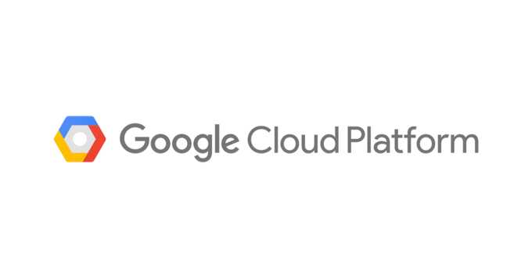

**Fall 2022- CS 3300**

**GCP Setup Guide (Adapted from materials in CSE 6242)**

## **Getting Started**

**A video tutorial has been created to help walk through the steps of GCP setup.**

**You can watch the video for:**

* **Creating** [**Project**](https://youtu.be/KVsepW9v4m0)
* **Creating** [**Bucket**](https://youtu.be/OinPd_6hJT4)
* **Creating** [**Cluster**](https://youtu.be/69iuOI36TQs)

**NOTE:**

1. **Ensure you are using personal GMAIL account. Do not use GMAIL account associated with any organization or university.**
2. **This setup guide is designed to help students quick start GCP Setup and assumes the GMAIL account used is setting up GCP account for the first time. The screens might vary based on your GCP account and this is excepted. Use this guide as a starting point and as a heuristic to identify and setup the GCP Storage buckets and Dataproc Cluster on your own based on the vagaries of your Google Account.**

**(Students are expected to setup the storage buckets and the clusters on their own. This guide is for reference only, and is not meant to serve as a step-by-step guide due to the variations in individual google accounts)**

Instructions to setup GCP Storage buckets and Dataproc Cluster are provided below:

Please make sure you have a Google account and if you don’t have one, you would need to create a new account.

1. Login into your account using this [link](http://accounts.google.com/)
2. Access your GCP coupon through the link provided to you on Ed.
3. Enter your free educational credits using this [link](https://console.cloud.google.com/edu?_ga=2.247808965.356410465.1600383459-904960821.1584270766).

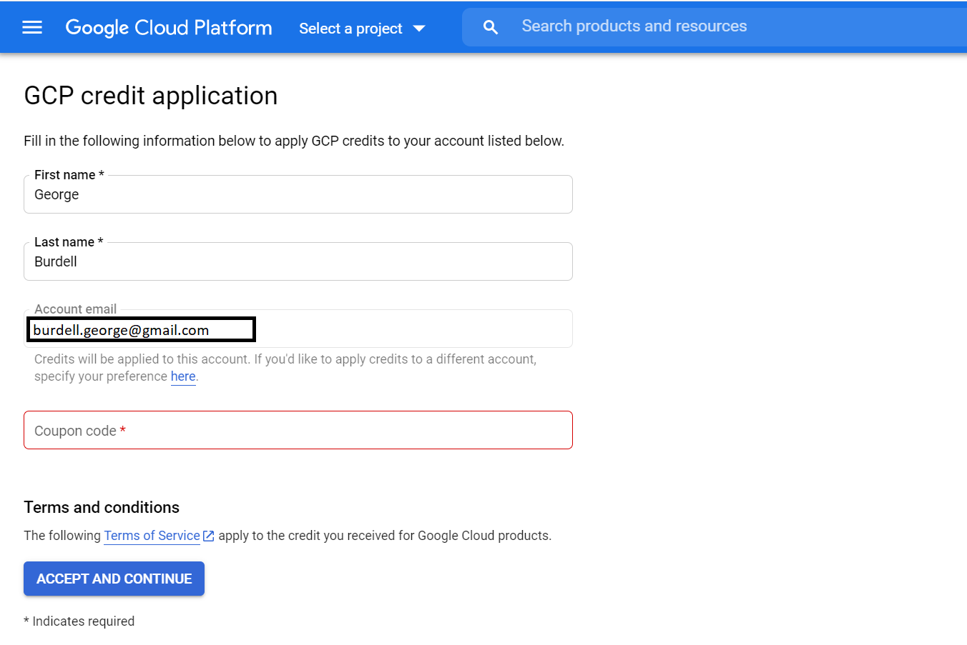

1. When you enter the educational credits, Google automatically creates a new billing account named “Billing Account for Education” and activate the “free trial option” at the top right corner of the console.

**Note: You might not need to activate if you have previously used GCP with educational credits.**

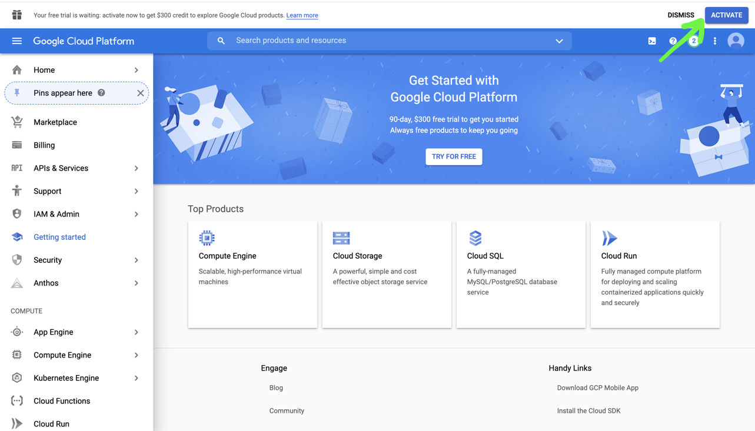

1. You will need to enter default billing credit card information if you are using GCP for first time. This is to confirm it is a human and you may need to give your personal credit card details for billing (money would not be deducted from your card). Please make sure to use the billing account named “Billing Account for Education” is linked to a new project which will be used to create your storage and clusters (details in step 7). Don’t use your own personal billing account otherwise the free educational credits will not be applied.

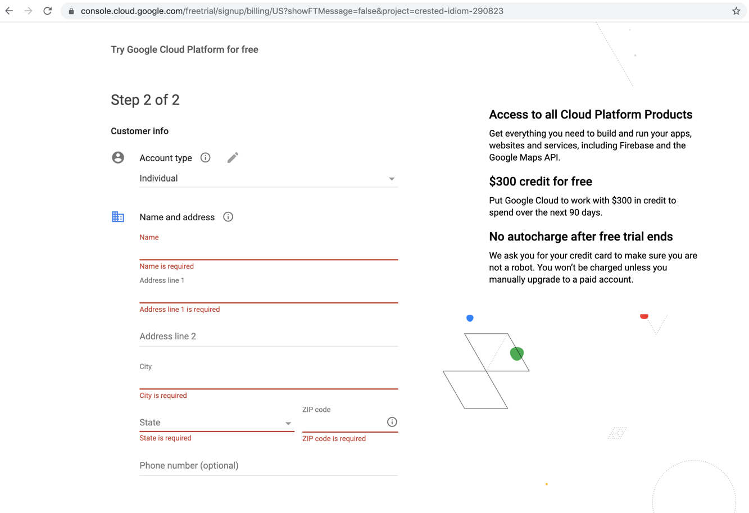

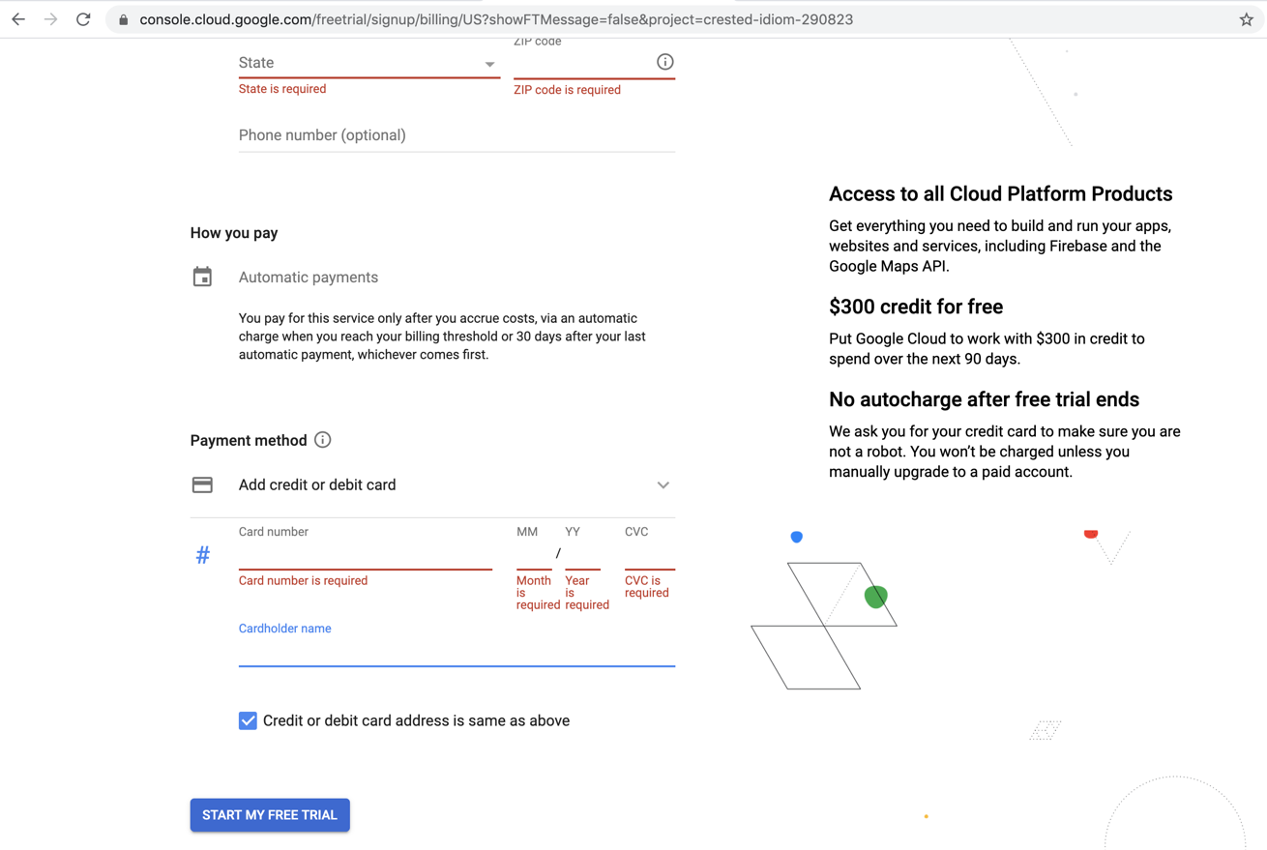

1. Go to [Google Console Home](https://console.cloud.google.com)
2. On the top left menu on the blue banner, click on dropdown to “**select a project” (or if you already have existing projects, it will list the latest project. Click on the drop down in this case as well)**

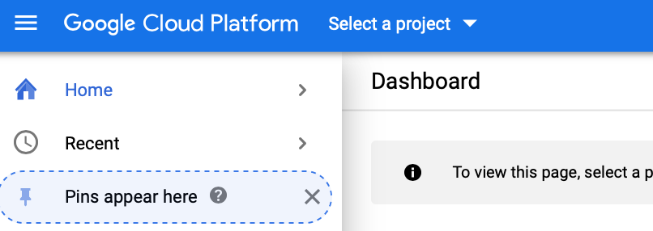

1. Click on New Project on the top right corner

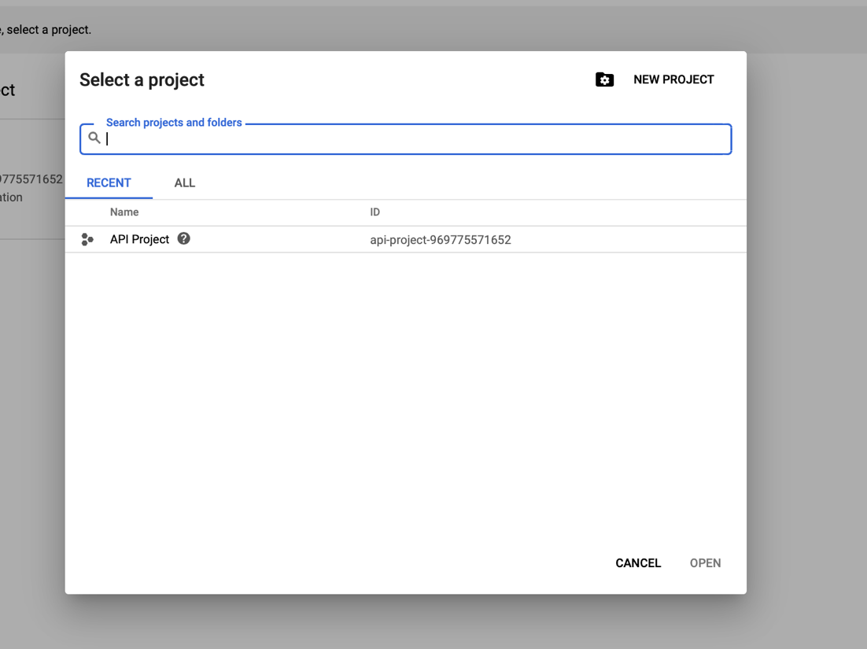

1. Enter CS3300 (or any other default name) and create a new project

**Note: The new Project CS3300 should be linked to the Billing Account “Billing Account for Education”. This step can be achieved while creating a new project in step 7 as listed above. If you have only one billing account (namely Billing Account “Billing Account for Education’’, it will automatically link your project to Billing Account “Billing Account for Education”.**

1. Wait till the new project is created.

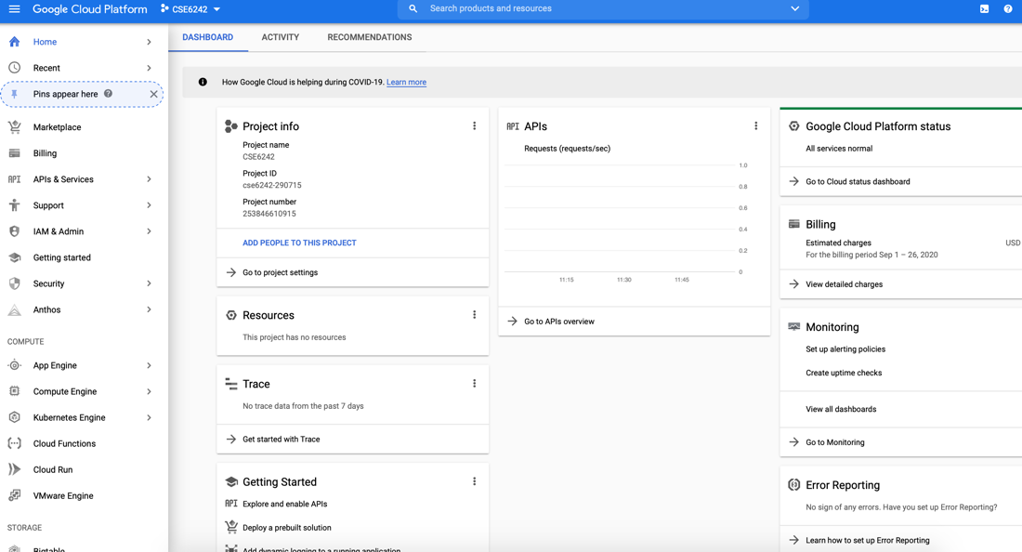

### **Delete Storage and Clusters**

**Do not leave the storage and cluster running once you are not using it.** Please remember to delete both storage and clusters. The deletion process is easy.

**NOTE: Ensure to download all the notebooks from GCP cluster before deleting the GCP cluster (otherwise the work will be lost).**

1. On the Storage home page, check the bucket you want to delete and then click “DELETE.”
2. Wait till the bucket is deleted without any errors.
3. On the Cluster page, check the cluster you want to delete and then click “DELETE.”
4. Wait till the cluster is deleted without any errors.